Sonoran Desert Food Chain . . . Web . . . Pyramid

What’s hot and cold and dry all over? It’s the desert! The desert is a place of extremes. In this activity, you’ll build a desert food chain, turn that into a food web and finally, a pyramid! All the while, discovering the plants and animals that can survive in these challenging conditions.

When you think of a desert, what do you imagine? We often think of deserts as hot, dry places, but sometimes they can be cold and dry as well. We often refer to them as extreme environments because in addition to challenging temperatures, they receive very little rain.

Deserts around the world have different species of animals and plants, but these animals and plants share certain characteristics. They all need to be comfortable in arid, or dry, climates. Some plants have adapted to store water in their stems, roots or leaves – these are succulents. An agave is a leaf succulent. Others, like cacti, have thick or waxy skins, called a cuticle, that prevents water loss from its cells. Some plants have very small leaves, another way to slow water loss. In the Sonoran Desert, the mesquite tree is one example of a desert plant. The tree has small leaves and a deep taproot that helps draw moisture up from the soil.
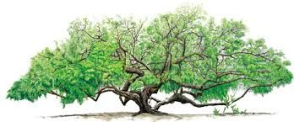
Animals living in the Sonoran Desert find their own ways to stay cool – coming out to forage only early in the morning or early in the evening (crepuscular behavior) or only at night (nocturnal) – to avoid the heat of day.

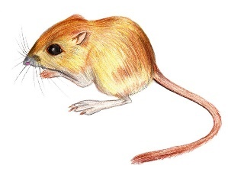
The kangaroo rat harvests the seeds of the mesquite tree and stores them in underground burrows. Some species of this small rodent don’t drink any water at all, getting all the moisture they need from the seeds that they eat.
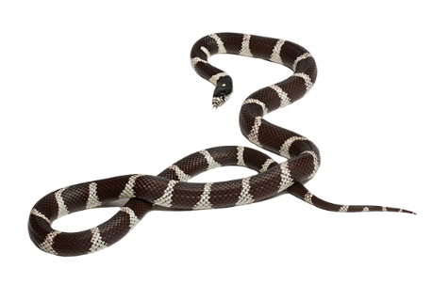
Non-venomous kingsnakes eat kangaroo rats, as well as lizards, birds, eggs and even other snakes. Like other ectotherms (cold-blooded animals), kingsnakes cannot regulate their body temperature, but have to move in or out of the sun to warm up or cool off. In the Sonoran Desert, they are mostly crepuscular like many of their prey.
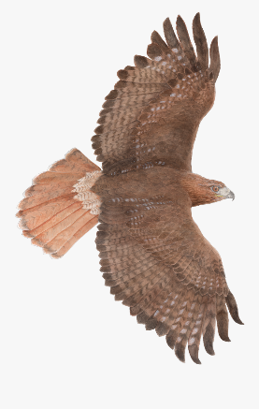
Among other things, the red-tailed hawk eats snakes. This hawk is adapted to living in many different environments, having the ability to fly long distances to find food and water. Except for man, there is really no other animal that will prey on a hawk, so they are considered apex predators – at the top of the food chain.

In this activity, you’ll build a food chain, a food web, and a food pyramid using the Who Eats Whom photo ID cards from Tohono Chul’s Eco-station. First, let’s learn what each term means and how each model is different.

Creating a Food Chain
A food chain is a simple line of organisms, each dependent on the next for food. You can begin with the sun and rain/water as those are the elements that plants depend on to grow. Otherwise, all food chains begin with plants - plants are producers because they make their own food. For our desert food chain, you might start with the mesquite. Next you will select a primary consumer, an animal that depends on plants for its food, such as a kangaroo rat that collects mesquite seeds. Next, you might choose a secondary consumer – a gopher or kingsnake who in turn might be eaten by a tertiary consumer such as a hawk. Or the hawk might eat the rat itself!

1. Print a set of WEW Activity Cards and cut them apart.
2. On a bulletin board, pin the appropriate photos in order – sun, rain, mesquite, kangaroo rat, snake, hawk.
3. If you don’t have a bulletin board, tie a sturdy piece of string from one side of the room to the other and hang your photos with paper clips.
4. You’ve made a food chain – plant feeds rat feeds snake feeds hawk!
5. You can also try mixing up your organisms, starting with a different plant (remember, sun and rain always come first) and deciding who eats it and who gets eaten in return.

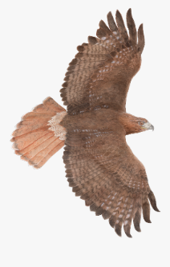
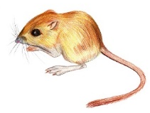
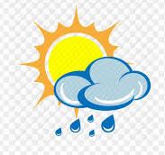
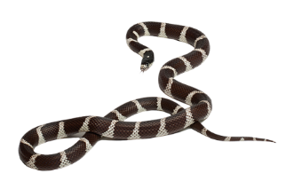

Creating a Food Web
Life in the desert is more complicated than this, of course. You eat a lot of different foods during your day, and each of those foods comes from a different place. In other words, you have an omnivorous diet. The same thing is true of many organisms in the desert. Each herbivore, or plant-eater, eats a number of different plants, and the carnivores, or meat-eaters, eat a number of different kinds of animals. Some organisms eat both plants and animals, making them omnivorous. A kangaroo rat might try the seeds of a ripe prickly pear fruit as well as the seeds from a mesquite or even a grass. Snakes eat lizards and birds as well as rodents. Adding complexity to your food chain turns it into a food web.

1. On the bulletin board, try connecting the elements of your food chain with yarn.
2. Next, pin an owl up and connect it to the kangaroo rat; now, pin a lizard next up and connect it with yarn to the snake.
3. How about connecting the owl to the snake as well, or add an insect and connect it to the lizard?
4. If you are hanging your photos from a string, connect additional images with paperclips, making new food chains that hang down and connect across each other.
5. Can you see a pattern forming? This pattern looks more like a web than a chain. Keep asking yourself “Who Eats Whom” and see if you can add other plants or animals to your web!

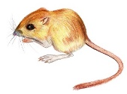
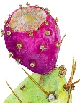
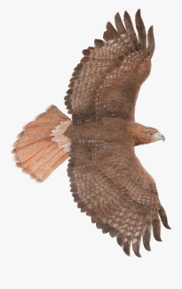

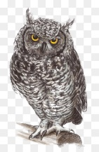

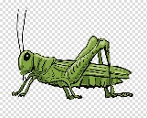

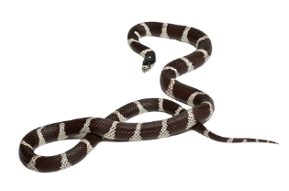

Creating a Food Pyramid
A food pyramid is different from a food chain or web. Think about that kangaroo rat. How many seeds does it take to feed your rat? Probably hundreds. How many rats does it take to feed your snake? One every day or two? How many snakes would a hawk eat in a week? As you move up the food chain, each level can support fewer animals. Each level of the pyramid is called a trophic level, the position an organism occupies in a food chain. A single hawk (ultimate consumer or apex predator) can eat many snakes (secondary consumer), and a single snake can eat many rats (primary consumer). Each kangaroo rat eats hundreds of mesquite seeds, which we call producers because plants produce food through photosynthesis (getting energy from the sun). This means that thousands and thousands of seeds end up indirectly feeding that hawk at the top of the food chain. A food pyramid shows the different numbers of organisms that are necessary at each level of the food chain. At the bottom of your desert food chain, you might draw many different seeds, but there will be only one hawk in the small triangle at the top.

1. Have you decided what animals and plants you’d like to have in your desert food pyramid? Yes? Then let’s build it!
2. First, cut out the template on the next page along the outer lines, including the little tab at the top.
3. Next, start folding. Fold the paper diagonally, unfold it, and fold it again in the opposite direction.
4. From bottom to top, label the four parts of the middle triangle with the names of the plants and animals you used in your food chain. You’ll begin with the plants at the bottom and put the name of the top predator at the top. Remember: the mesquite seeds are the producers, the kangaroo rat is the primary consumer, the snake is the secondary consumer, and the hawk is the ultimate consumer.
5. On the third triangle, draw a picture of each plant or animal in your pyramid.
6. To complete your desert food pyramid, tape the tab on your first triangle to the underside of your third triangle. You’ve made a food pyramid!

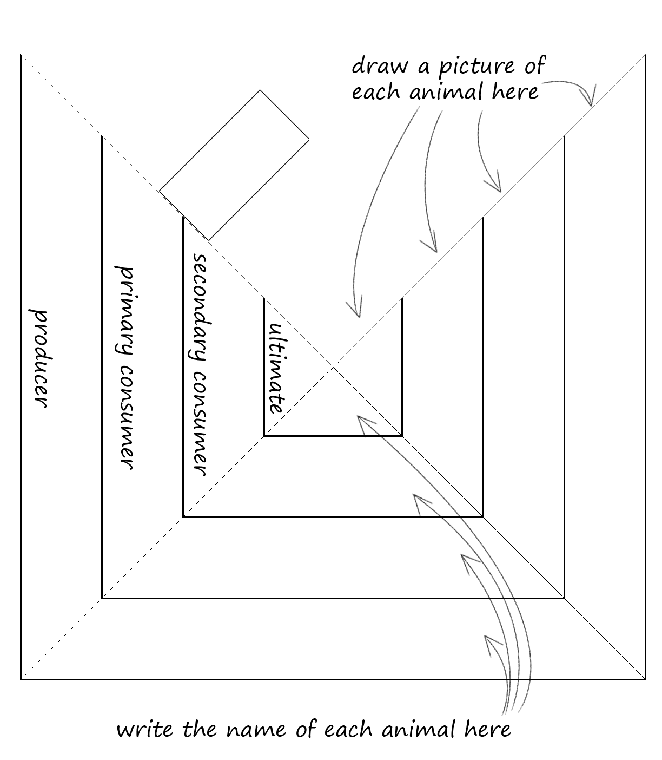
draw a picture of each
plant or animal here
write the name of each plant or animal here

